Draft 6 (February 2011)
ME72: Engineering Design Laboratory
“Extreme Recycling”
Contest Description and Rules
Twenty-sixth Annual Engineering Design Competition
1-3 pm, Tuesday, March 8, 2011

1. Introduction and Overview
Your mission this year is to design, build, and deploy a team of vehicles that will traverse difficult terrain in order to
- Gather a variety of recyclables
- Correctly sort recyclables into bins
- Return your vehicles to the start zone by the end of each heat.
The final contest will take place at 1pm on Tuesday, March 8, 2011 at Beckman Mall (the grassy stretch just south of Beckman Auditorium). In case of inclement weather or other unforseen events, the contest will take place on the following day, Wednesday, March 9th. The contest will be a double-elimination tournament, in which teams of three or four students will compete in head-to-head heats. Each team will have 45 seconds to place their system within a “starting zone” (see Figure 1), and then a 5 minute period during which all of the scoring takes place. More details about each aspect of the contest are given in the following sections.

2. Key Contest Time Periods
The overall contest period is divided into rounds. Each round will consist of heats between all of the teams remaining in the competition, where a heat consists of a head-to-head competition between two teams. After two losses, a team will be eliminated from the competition. Every remaining team will compete exactly once per round. If there are an odd number of teams, one heat will be a “bye” – a competition between a team and a TA-made placebo vehicle.
Each heat is divided into these main intervals:
- Set-up Period. The contest judge(s) will instruct the competing teams to place their entry into their starting zones. Teams must complete this initial setup within 45 seconds. At the end of the 45 second period, or earlier if both teams’ entries are ready (at the discretion of the contest judge), the “go signal” will be given, starting the competition period.
- Competition Period. From the onset of the “go signal” at the end of the set-up round, each team has 5 minutes to score as many points as possible—this is the “competition period.” Until the end of the competition period, teams may engage in both offensive and defensive behavior, as outlined in more detail below.
- Clean-up and Removal Period. At the end of the competition period, both teams must remove their vehicles and any debris from the competition field within 30 seconds. During this period, the next heat’s contestants will be setting up their devices.
3. Overview of the Contest Arena
This section describes the overall geometry of the contest arena. The next sections will clarify how to score in this arena, and provide additional details for each key contest arena component.
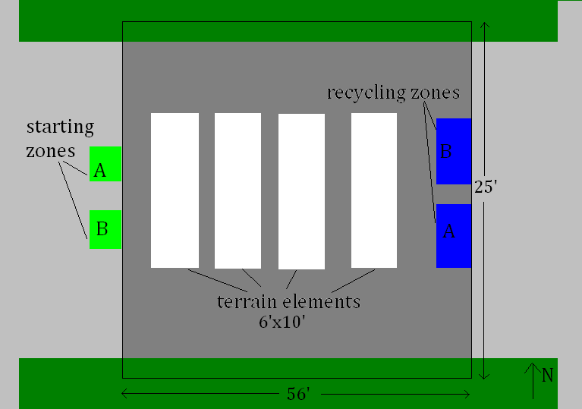Figure 1: Floor plan of the main contest arena. Note: the diagram is not drawn to scale. Details of key components are given in subsequent figures.
3.1 Overall Geometry and Physical Limitations of the Contest Arena. The contest arena consists of clearly marked 25-by-56 foot section of the central, crosswise sidewalk on Beckman lawn. The arena extends upwards, forming an allowable airspace of up to 10 feet from the terrain surface at every point. No vehicle, part of a vehicle, or recyclable may reach higher than 10 feet from the surface at any point in the contest; teams that do so may be disqualified at the discretion of the contest judge. No part of a vehicle may leave the marked contest arena during the competition period. Vehicles leaving the contest arena may be disqualified at the contest judge’s discretion.
3.2 Starting Zones. Starting zones are located on one side of the contest area, as shown, and will measure 4 feet wide by 3 feet deep. They will be placed symmetric to the center line, with 6 feet in between the two teams' starting zones. At the beginning of the set-up period, team members must be within a 3-foot radius of their starting zone, and remain in that region until the beginning of that heat’s competition period (after the vehicles have entirely departed from the starting zone). All vehicles being used in the heat must begin in the starting zone. Zone geometry is detailed in Section 4, Figure 2.
3.5 Allowed Movement of Contestants. After the launch period, team members may move within the starting zone and around the outside perimeter of the contest area. These areas will allow vehicle drivers a better view of their machines so that they can be better monitored and controlled. However, from the beginning of the launch period until the end of the heat, no team member, or any other person, may have contact with their system components. Moreover, no team member, other person, or mechanical device may interfere with the movement or activities of their human competitors during the setup, launch, competition, and clean-up periods. Such interference may lead to disqualification.
3.6 Terrain. Each of the terrain elements will be 6 feet wide and 10 feet long, with varying heights. The following elements will be included, although not necessarily in the order given:
- Water element. The water element will consist of a wooden box, lined with plastic, of no taller than 3.5 inches. Water depth will be between 1.5 and 2 inches. The water element will have ramps on the inside as well, of the same dimensions as the exterior ramps.
- Sand trap. The sand trap will be a wooden box, no higher than 3.5 inches. The box will be filled up to 1” from the top, but will not be overflowing.
- Rock field. The rock field will contain 3”-5” Mexican river rocks, examples of which can be found in the ME shop. The box containing the rock field will be no taller than 3.5”.
- Mystery element. Contestants will not know the mystery element until the day of the dry run. Possible mystery elements include a dirt pile, grass, mud, gravel, or ice.
All the terrain elements will be placed in parallel to each other, with ramps on the north and south sides. Ramps leading up to terrain elements will have a slope of no more than 30 degrees, and will be at least 2’ wide. There will be at least 2 ramps for every terrain element.
There will be an easily-traversable (concrete and grass) path to the recycling zone. However, to encourage terrain-capable vehicles, the easy path will be longer and sparsely populated with recyclables. More recyclables will be placed in or past more difficult terrain. In addition, the easy path will have several chokepoints, in which teams can block each other.
3.7 Recyclables
There will be a total of 60 recyclables placed about the course, with more items and more valuable items in hard-to-reach places. The proportions and will be as follows:
- 30 plastic water bottles
- 20 aluminum cans
- 10 steel cans
Examples of each type of recyclable may be found in the ME machine shop. Teams may fold, bend, melt, crush, or otherwise mutilate recyclables, subject to the Safety Rules detailed later in this document. For an object to be counted as “recycled”, the majority of its mass must end up in the correct bin, at the discretion of the contest judge.
For the first two rounds, there will be 6 recyclables (2 of each type) distributed throughout the non-terrain-element parts of the course, placed at the discretion of the staff. This number will drop in the third round to 3 recyclables (1 of each type), and in all subsequent rounds to 1 recyclable of unknown or random type. For all rounds, the remainder of the recyclables will be distributed evenly throughout the terrain elements, with the exact placement at the discretion of course staff, and subject to change.
3.8 Recycling Zones. In order to score points for collected recyclables, vehicles must deposit recyclables in the recycling zones. Recycling zones will be located on the far end of the contest arena from the starting zones. Each team’s recycling zone will be placed on the side closer to their opponent’s starting zone, such that teams will have to cross paths with their opponents to reach their recycling zone. Within the recycling zone will be bins for sorted recyclables, as detailed in Section 5, Figure 3. Any recyclables within that team’s recycling zone but not in bins will be counted as “commingled recycling” and will count for half as many points as those in the bins.
Vehicles from one team may not enter the opposing team’s recycling zone. They may, however, attempt to block access to the recycling zone.
3.4 Finishing Zones. To gain extra points, all of team’s vehicles must finish back in their starting zone. For those points, the entirety of every vehicle must be within the starting zone, at the discretion of the contest judge. Details are given in Section 5 and in Figure 2.
3.8 Demarcation of Contest Zones. All contest zones and boundaries will be clearly delineated with masking tape or spray chalk.
3.9. Possible Interactions between Competing Machines and Competing Teams. You may not interfere in any way with an opponent’s devices during the set-up period. You may not enter your opponents starting zone or recycling zone. You may not prevent or interfere with your opponents exiting their starting zone at the beginning of the competition. However, once all of your opponents’ viable mobile competing devices have left the starting zone, you may block reentrance to their starting zone. A device will be deemed viable if it makes any movement during the first 5 seconds of the competition period. Devices which have not produced any movement during this period will be automatically unviable. Additionally, a contest judge may declare vehicles unviable at any time. The declaration of unviability is at the sole discretion of the contest judges, but will generally be applied when it is readily apparent that a component or vehicle is disabled, or intentionally left immobile by a team as part of their strategy.
While you may block, impede, annoy, or otherwise slow down your opponent during the competition period, you may not cause intentional damage to your opponent’s system. Pushing, shoving, ramming, blocking, and flipping are allowed strategies. Grabbing a vehicle in a manner which will not cause harm is allowed. However, grabbing operations that may cause perforation or other damage will result in disqualification. The contest judges will disqualify a team for what is deemed intentional damage. To reiterate, pushing, shoving, and blocking is explicitly allowed even if it results in devices flipping over or falling off from the elevated contest areas. Contestants should design their vehicles to survive such physical actions. Intentional tearing, stabbing or striking so as to dislodge components on opposing vehicles is not allowed. Additionally, devices must avoid creating entanglement hazards such as dangling nets or strings which may ensnare and damage motors, shafts, and propellers.
You may not modify, or intentionally block, the radio control signals emitted by an opposing teams’ transmitter. Intentional damage to any receiver/control module will result in disqualification. Each team’s transmitter/receiver pairs will have a different frequency to minimize interference. However, past experience suggests that you should expect some sporadic radio interference during the contest. It is your responsibility to avoid damage to the receiver/control modules during the design, fabrication, testing, and contest phases. Competitors should avoid placing their receiver/control modules in a vulnerable position within their devices.
4. Starting Zone and Starting Procedure
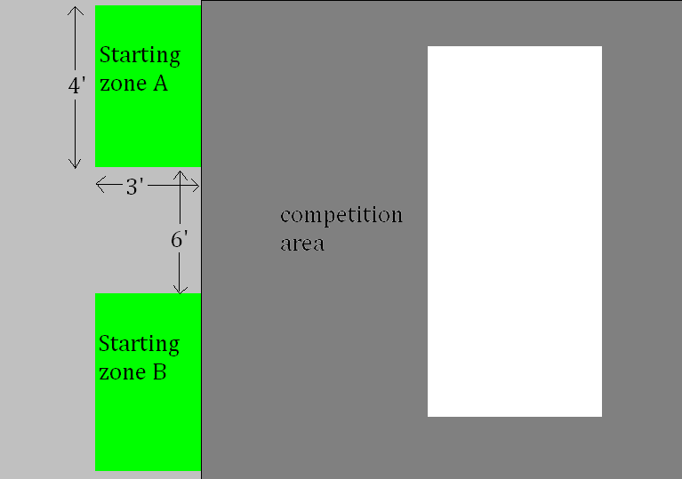
Figure 2: Detailed depiction of launching zone.
- Prior to each heat, a team will be given 45 seconds (beginning with the judge’s start command) to place their device(s) within their starting zone. All of the team’s components that will be used in that heat must be initially placed within that starting zone.
- For sake of efficiency, contest judges will notify teams that they are “on deck” for the next heat. Any team “on deck” must be able to start their set-up procedure at a moment’s notice.
- Two starting zones (one for each team) will be available for each head-to-head heat of the competition. They will be placed 6 feet apart, symmetrically located about the midline of the competition zone (see Figure 2). Teams will be assigned to their specific starting zone (i.e., the left or the right zone) by the contest judges.
- Each team’s starting zone will consist of a box with dimensions given in Figure 2. The horizontal dimensions will be indicated by tape or chalk on the sidewalk surface (with the permissible area including the tape itself). No part of a vehicle may exceed 10 feet above the contest terrain at any time before or during the contest. The vertical height constraint will be checked by the contest judges as necessary at the beginning of the heat.
- During the 45 second set-up period, passive mechanical energy, up to the limits described in Section 7, can be stored in a team’s entry. This energy can come from the contest motors and contest battery pack, or from team members’ muscle power. NO external electrical connection can be made to the system during the setup, launching, or competition phases.
- Each system must have a launching procedure that can be simply activated by operation of a radio-control system command. From the beginning of the heat (end of the set up period) until the end of the heat, contestants may have no physical contact with their device. Pushing, throwing, or kicking of devices to enable launch is not allowed.
- During the set-up and launching phase, all of the team’s contestants must be located within the area around the starting zone (see Figure 1). During the set up period, contestants may not interfere with their competitors’ devices or their set up procedure.
- Some teams may choose to design and build systems containing multiple components—i.e., different vehicles whose characteristics are optimized to beat different types of opponents. This is permitted as long as: (1) the ensemble of ALL devices together count towards the budgetary constraints detailed elsewhere in the rules, (2) and ALL devices can fit simultaneously inside the starting zone. However, any device which will not be used during a particular heat need not be placed in the starting box at the beginning of that particular heat.
- At the end of the heat, all parts of your system must be removed from the starting zone and contest arena within 30 seconds. Failure to do so can result in a loss for that heat.
- To reiterate, you may not interfere with your opponents or their vehicles at any time during the set up procedure. You may not enter your opponent’s starting zone, and you may not block them until all their vehicles have left the starting
5. Scoring
Each team can score points in the following ways.
5.1. Commingled Recycling. At the end of the contest period, all recyclables inside the recycling zone but not inside a bin will count for the values as follows:
- Plastic water bottles: 0.5 points
- Uncrushed aluminum cans: 1 point
- Steel cans: 1.5 points
- Crushed aluminum cans: 2.5 points
Note that these point values are half of those for correctly sorted recyclables.
A can will be considered crushed if it is less than half of its original vertical height, with individual judgments at the discretion of the contest judge. Sideways crushing alone will not be sufficient. Recyclables that are on the line will count as being inside the recycling zone, but an item must be entirely within the recycling zone to count.
5.2 Recycling Bins. Each of the 3 recycling bins will measure at least 1 ft x 1 ft, with a height of 12”. To score the “sorted recyclables” point values given below, vehicles must correctly deposit recyclables into their proper bin.
- Plastic: 1 point each
- Aluminum:
  - 2 points for each uncrushed aluminum can
  - 5 points for each crushed aluminum can
- Steel:
  - 3 points for each uncrushed steel can
  - 6 points for each crushed steel can
Correctly sorted recyclables will count for the point values as given; incorrectly sorted recyclables will only count for half their value, as they are still in the recycling zone and thus count as “commingled recycling”. Bins will not be labeled. You may choose the order in which to place your sorted recyclables (ie you choose if you want plastic-steel-aluminum or aluminum-plastic-steel). When the heat ends, before recyclables have been counted, your team must declare which bin contains which category.
Bins may not be intentionally moved, tampered with, or knocked over. In the event that a recycling bin is tipped over, those recyclables that still remain in the bin will be counted for the sorted points, at the discretion of the contest judge. Those that fell out of the bin will count toward commingled recycling. Vehicles may attach to a bin, but teams must avoid permanent damage to the bins, at the risk of disqualification.

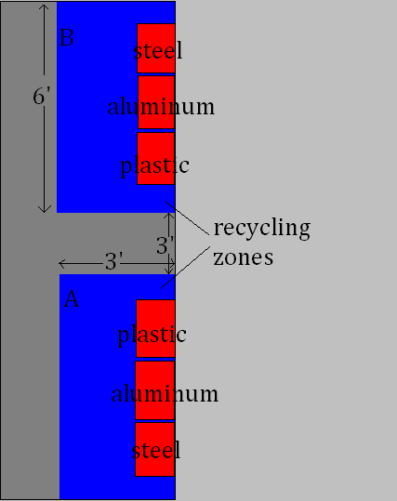
Figure 3: Details of Recycling Zone. Note that recyclables may be sorted in any order; steel cans can go in the middle bin, for instance.
5.3 Finishing Zone. If, at the end of the contest period, all of a team’s vehicles are in their starting zone, the team will gain an additional 10 points.
5.4 Scoring Clarifications and Prohibitions. Teams may not launch with recyclables onboard; all recyclables deposited in bins must come from the contest arena.

6. Evaluation
The team with the highest score at the end of a heat’s regulation period (and satisfying the constraints outlined above) will be declared the winner of that heat. If the score is tied, the following tie-breaker formula will be used. The team who first returned all their vehicles to the launching zone will be declared the winner. If this procedure does not resolve the tie, then both teams will be assigned a “win” for that heat. If neither team scores during a heat, then both teams are assigned a loss for that heat. In all cases (particularly those requiring judgment) the judges decide the winning and losing outcomes of a heat.
The overall winner is determined in a double elimination tournament. This is just like a single elimination tournament, except a team must lose twice to be eliminated from the competition. The head-to-head competition and double elimination format is chosen so as to eliminate, as much as possible, the effects of transient conditions (e.g., wind, sun, and rain) and other random factors on contest performance. Your device must be robust enough to survive repeated contest rounds. Basic mechanical repairs to your device are allowed between heats (see Section 7.6).
Pairing of teams in each heat will be chosen randomly at the start of each tournament round. Therefore, teams must be able to compete at a moment’s notice once a new round begins.

7. Mass, Volume, and Material Constraints.
In the past, we have given teams a “kit list” of materials from the shop that they are allowed to use. This year will be different. Each team will be given a budget of $500, which they may use to purchase materials from the shop, or to order materials online.
7.1 Budget. We have found that teams have a tendency to underestimate the importance of prototyping. Although there is no mandatory breakdown of spending between your prototypes and your final competition vehicle, we highly recommend that you spend at least 25% of your budget on prototypes. In the past, the teams that do the best are those that prototype early, and play around with a number of different design concepts.
We will ask you to keep track of all your expenditures as they occur, and to present us with budget estimates at your PDR and CDR. Although exceeding your budget will not hurt your team’s chances in the competition, you will be graded on your team’s ability to stay within budget. In addition, any team exceeding their budget by more than %150 will be cut off from buying new parts.
Orders from websites such as McMaster Carr should be placed through John. Orders from other companies must be approved by ME 72 staff, and can be placed by John or the students.
7.2 Energy and Actuation Sources. Teams must “purchase” all of their energy sources and actuators. All of the following electrical components are available in the shop, and may be purchased freely. Use of outside electrical components is discouraged, and items must be OK-ed by the staff on a case-by-case basis.
- “small” battery packs that are designed to power radio-control receivers.
- hobbyist servo-motors ( “small” and “medium” sized).
- large battery packs (which are designed to power motors and motor controllers). You may only use the battery packs and chargers from the shop. However, you may use as many battery packs as your budget allows. Please see a TA if you intend to string multiple batteries together. We recommend using no more than 1 battery pack per speed controller, because using more will burn out the speed controller (against contest rules).
- “large” brushed D.C. servomotors and “small” brushed D.C. servomotors. Speed controllers are also available for these motors.
- Energy may be stored passively in elastic members or in compressed materials (e.g., compressed air), as long as these energy storage components are made and energized from prescribed contest materials and energy sources. The stored energy must also conform to limits that are described below.
- standard model-airplane radio-control transmitters, each having 6 channels of control that can be used to remotely control the hobbyist servos and the D.C. servo motors (through the use of an optional D.C. speed controller).
These radios and receivers cannot be modified in any way; they must be used in the format as they are provided to you. Note that these transmitters can be reprogrammed in different ways in order to simplify the use of their joystick inputs. You may only use the radio transmitters and receivers from the shop. Similarly, the battery packs provided cannot be chemically or thermally altered.
You may buy motors, gears, and transmissions from outside sources... but you may not use any pre-geared motors or other motor-gear combinations. You may ONLY use the blue speed controllers (not the orange ones, not anything bought elsewhere). In general, you must use the radio controllers, speed controllers, and batteries from the shop (there may be exceptions if you have a good reason). You may use motors from outside vendors. You may not buy and use entire assemblies, except for transmissions (but dismantling something and using part of it is OK).
Students will have access to an ample number of battery chargers throughout the course and during the contest. However, design teams may choose to purchase additional battery packs if so desired in order to ensure maximum charge during the contest. Additionally, batteries will be provided during the testing and contest period for the hand-held radio control modules. The battery packs may not be modified in any way at any time (mechanically, chemically, thermally, electrically, etc.); they must be stored and operated at ambient temperature. Depleted radio control module batteries can be recycled in the M.E. Shop.
7.3 Passive Energy Storage Limits. There will be limits on the amount of mechanical energy that can be stored in your devices prior to the initiation of the launch sequence. This energy may be obtained by deforming any elements in the prescribed material list, or by compressing air or other contest materials. The limit of such stored energy that prior to the start of the launch sequence will be 20.0 joules (approximately the amount of energy stored by deforming six (6) medium sized rubber bands). Testing and analysis that demonstrates conclusively that these limits have been met must be included in your design notebook, and approval of your analysis must be given by one of the class instructors. Note that gravitational potential energy can be used within the limits of the starting box and system volume constraints (see Section 7).
7.4 Contest Materials. Electronics will be restricted to those provided in the Mechanical Engineering Shop, as detailed in the previous section. Of course, teams may chose to forgo certain electronics, in order to save money. However, you may not purchase motors, batteries, speed controllers, or any other electronic components from any outside source without explicit permission by the ME staff.
Teams may purchase whatever non-electrical materials they want from sources such as McMaster Carr. In addition, they may use the following items available in the ME Shop free of charge.
(a) Glues and epoxies (including hot glue sticks) that are used only for bonding. Unlimited quantity may be used for bonding purposes only. A total of 4 ounces of glue or epoxy may also be used (in combination with other materials on the approved contest material list) to create a composite material, with glue as the matrix.
(b) Paint or Shellac may be used to insulate strands of wire. Similarly, up to 1 m of black electrical tape may be used for electrical insulation, but not for structural purposes.
(c) Light machine oil, mineral oil, or vegetable oil (depending on the competitor’s preference) can be used to lubricate moving parts.
(d) Up to 1 meter of adhesive tape may be used for sealing
Replacement supplies and materials are available on a limited basis. If you damage something, or cut it up, and then want to do something different with it, see the M.E. Shop staff. We will do our best to supply replacements, but we cannot guarantee unlimited supplies of all materials. We also cannot guarantee that replacements will be identical to the original. You may want to check availability of replacements prior to conducting a risky experiment with a rare part. In particular, each team member will be supplied with only one set of hobbyist motors and radio control system. If these devices are damaged, it is up to the students to replace them. Sources for these items can be found in the resources section of the class web site.
While some glues and epoxies will be available in the M.E. Shop, to ensure an un-interrupted supply, students should go to a (hardware) store, and buy their own.
Soldering and brazing are permitted, though not encouraged. Welding is not permitted.
7.5 Contest Entry Size and Weight:
(a) Size: Teams may have up to 2 mobile vehicles, each measuring no more than 18” by 18” by 12” in any direction. Stationary components may be of any size, with the stipulation that all of a team’s competition devices must fit in the team’s starting zone. A team may choose to make more than 2 mobile vehicles, and switch them out to deal with different opponent’s strategies. In this case, all possible vehicles used in the competition must be able to fit in the starting box. However, at the beginning of any given heat, teams may place only the vehicles they are using in the starting box.
(b) Weight: There is no specific weight limit on your team’s vehicles. However, we expect vehicle weight to be naturally limited by battery power, so we encourage you to do some calculations in your design notebook regarding the range, weight, and power of your vehicles.
7.6 Allowed Changes to Design on Competition day. After a device’s initial heat, no major design changes or construction will be allowed. It is inevitable that crashes and damage will be experienced during the competition. Repairs to your devices using materials will be permitted provided that, in the judges’ opinion, they involve no major design changes to the initial device. Pre-fabricated “spare parts” are only allowed if they have been included in the device size restriction and materials budget. Minor changes will be permitted. These minor corrections must respect the rules on size and materials described elsewhere.

8. Additional Contest Rules
8.1. Safety. Any device which may injure participants or spectators will be disqualified.
8.2. Team Number. Each team will be assigned a 2-digit integer number to identify their team and their contest device(s). Each major component of each team’s design must carry an identifying team number. Note that Number 00 is reserved for the contest placebo. While not required, teams are also encouraged to choose a team name, and perhaps a team logo.
8.3 Pre-contest testing. Prior to the final contest, participants are encouraged to test their devices. While we will endeavor to make sufficient testing time available at the competition location, we cannot guarantee that the location will be available for testing on any specific day.
8.4 Other intentional damage. Any intentional damage to Caltech buildings, grounds, or other Caltech infrastructure prior to or during the contest will result in disqualification.
8.5 Set-up and Clean-up Periods:
(a) After the end of the set-up time, but before the “go signal” is given, no action of a team’s device(s) is permitted. I.e., motors cannot work to store energy. Even during the set-up period, only those movements of the team’s mechanisms that are needed to place the devices in the launch region and to store passive mechanical energy (up to the contest limits) are allowed.
(b) A maximum pick-up time of 30 seconds (commencing from the end of the regulation competition period) will be allowed for removing all of your device(s) from the contest arena.
8.6 Bye Heats in the Tournament (the “Placebo” rule). If your team gets a bye in any round (because there are an odd number of surviving teams in that round), or your opponent(s) do not show, your team must be prepared to compete against a placebo device if so requested by the contest judges. In a placebo round, your vehicle must pick up at least one recyclable in order to win the round.
8.7 Authority of the Contest Judges. The course instructors and contest judges will attempt to resolve any disputes or gray areas in the rules using the spirit in which these rules were designed. However, the course instructors and contest judges have the final authority in all contest matters and decisions. Just like baseball, unprofessional arguing with contest judges can result in expulsion from the contest.

9. Individual Work
While you will be working in teams, it is expected that each individual will design and fabricate a significant portion of each functional device. It is acknowledged that interaction between teams in the class is highly beneficial. To that end, any conversations, calculations, analyses, ideas and tests may be shared among the teams, but the device design and fabrication must be an individual team effort. Note that this collaboration policy does not extend to replicating others’ ideas. Occasionally two teams will arrive independently at very similar solutions. Sometimes one team will see a great idea in another team’s device, and finding no superior alternative, will want to incorporate it. This duplication is permissible, however, not encouraged. In the past, some competitors have maintained a high level of secrecy around their device, and blindly copying an idea or strategy may be risky. In many respects, you should treat this design project as similar to an ordinary homework set. It is permissible to collaborate with your classmates and seek the advice of the instructor, TA’s, M.E. Shop staff, other class participants, and other students. However, the final product must be your own work. It is vital to document both your own work and the contributions of others to your ideas by detailing the process of ideation, design, and fabrication in your design notebook. If you are concerned about the acceptable limits to collaboration, discuss the situation with the instructor(s). Do your own work, and as always, it is best if you use your own ideas and concepts.

